Appendix 1: Assignment submission cover sheet
ASSIGNMENT SUBMISSION COVER SHEET
Student Id: cse25-420
Student names: Rethabile Ashley Lekgetho
Student email: cse25-420@thuto.bac.ac.bw
Cohort: 2026
Assignment title: SCIS WMD_2026 A01 YEAR 1
Date of submission:
Programme of Study: Computer Systems Engineering
Year of Study: YEAR 1

Intellectual property statement
By checking the box below, I certify that this assignment is my own work and is free from plagiarism. I understand that the assignment may be checked for plagiarism by electronic or other means and may be transferred and stored in a database for the purposes of data-matching to help detect plagiarism. The assignment has not previously been submitted for assessment in any other unit or to any other institution.
I have read and understood the Botswana Accountancy College plagiarism guidelines policy.
☑ Agree

Signature……………………………………. Date………10/05/2026……………………

Introduction
Aiju Smart Technology also known as Shenzhen Aiju Intelligent Technology is a tech company located in Shenzhen, Guangdong, Peoples Republic of China. It specializes in smart wearable devices and focuses on the development, production, and sale of smart audio glasses according to crunchbase.com.
The primary objective of the Aiju Smart Technologies platform is to serve as a high efficiency digital product catalog for international buyers, B2B companies and global tech distributors.

Problems
- Platform risk: It relies mostly on the use of Wechat which is an app used mainly only in China. If the platform shuts down the account, the entire business is lost.

- Credibility Gap: Most customers research on a company or business before enquiring about buying a product. Since Aiju smart lacks an online presence most people are not willing to purchase products since it does not seem like a legitimate business.

- Silent salesman: Since the company uses a mini program on Wechat, it operates like a physical store, it has opening times and closing times. This can be a hindrance for international customers because of the different time zones.

- Lack of online presence: The current website Aijusmart.com acts more as an information retrieval site more than brand storytelling or product marketing. It lacks information on products.

- Incorrect information: The contact information provided on the website and from other sources that wrote about the website e.g crunchbase.com all have contact information that is incorrect/ nonworking. The contact information provided does not work internationally since most western media is banned in mainland China.

REQUIREMENTS
- Create a platform where it owns its own data and it has control over their business. The business also becomes accessible globally.

- Credibility: Web presence shows that a business is legitimate especially if it displays its certificates. It shows that is an established, trustworthy and stable entity.

- 24/7 salesman: A website is unaffected by time zones. This makes it easier for international customers to review the products.

- Display and provide information about the smart wearable devices being produced and sold.

GOALS
- Enter global market: Aiju smart produces great level devices which have the potential to become the best next thing.

- Showcase great level of innovation by displaying the manufactured AI devices

- Produce a website catered for English speakers for easy navigation

TARGET AUDIENCE
- Regular customers
- Tech companies
- Wholesalers
- Tech enthusiasts
- Fitness enthusiasts

Information Taxonomy
SITE MAP
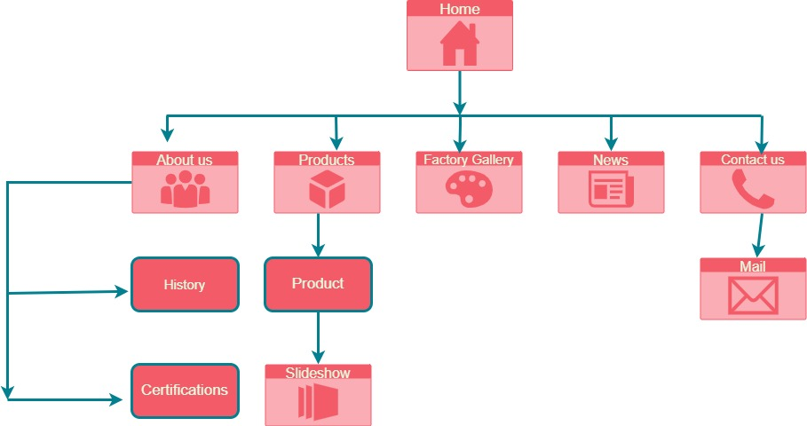

Template Design
homepage
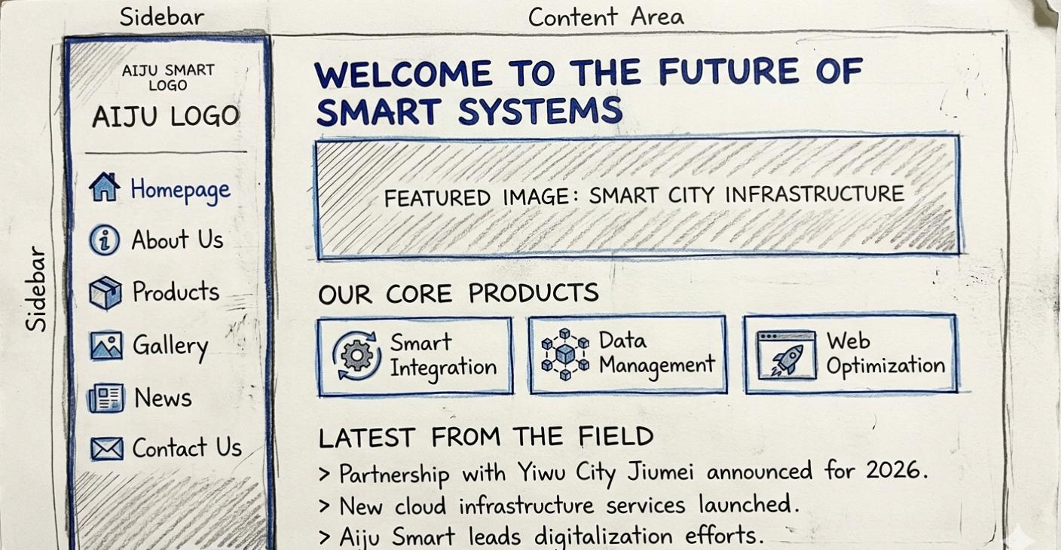
Products 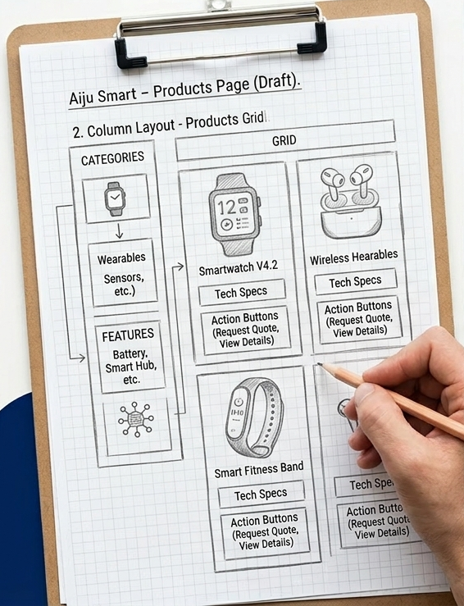

About us
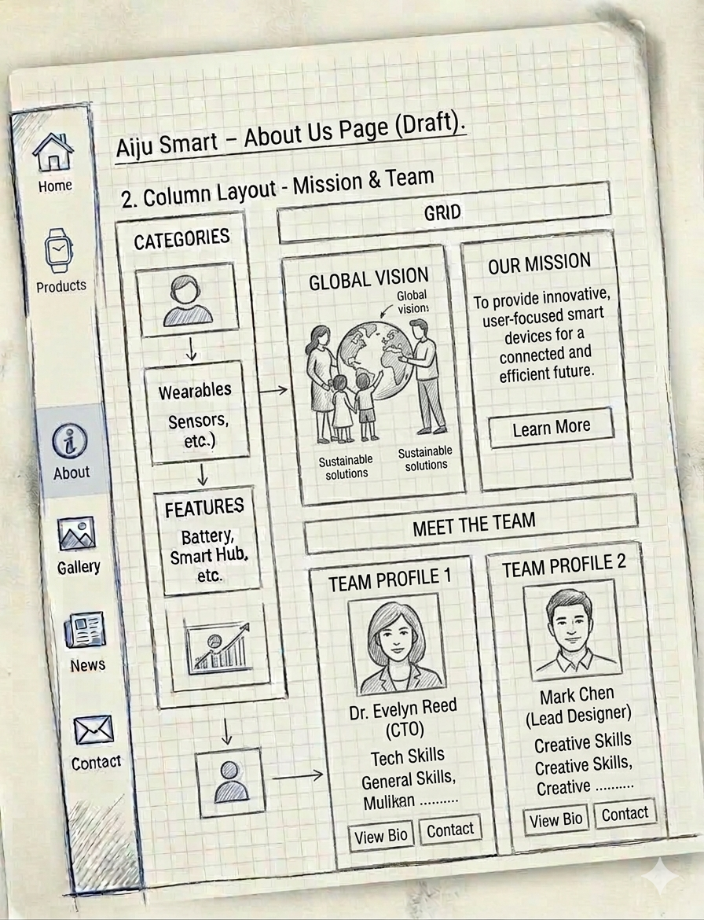
gallery
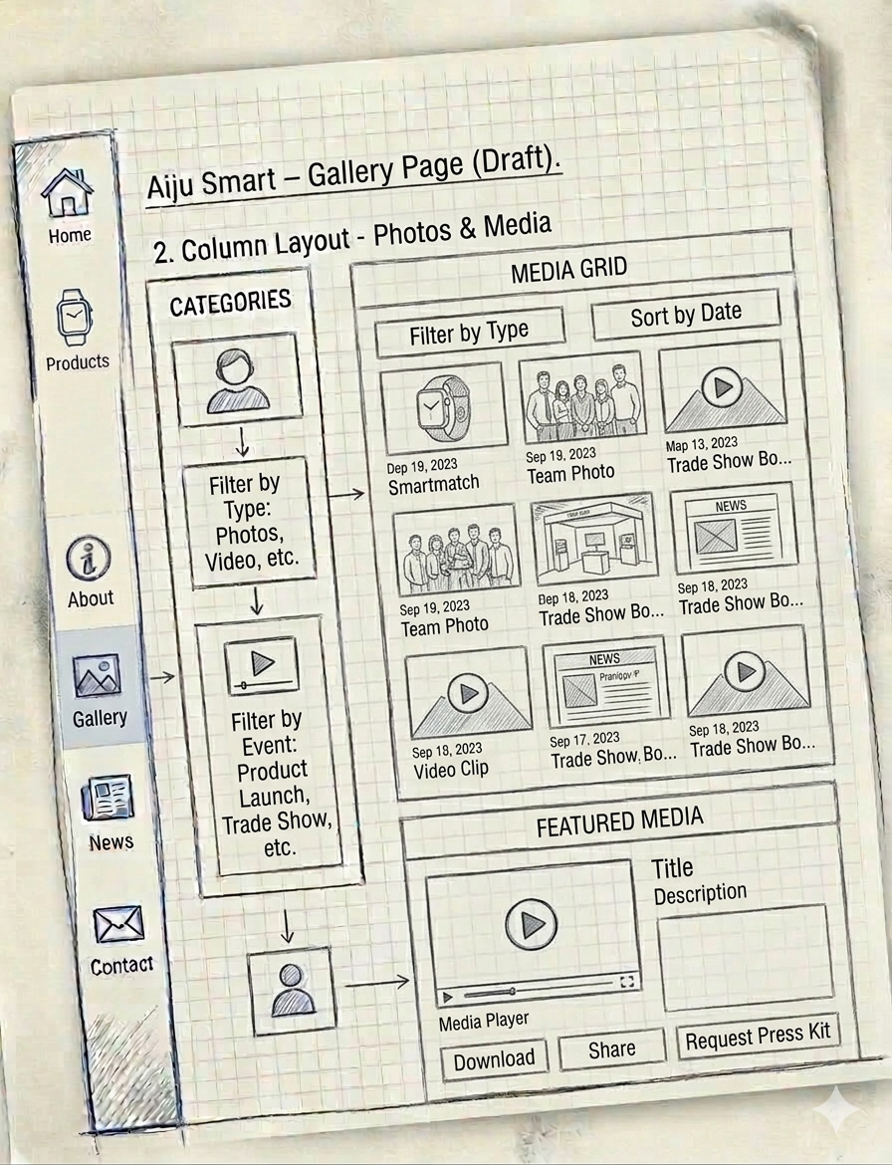
News page
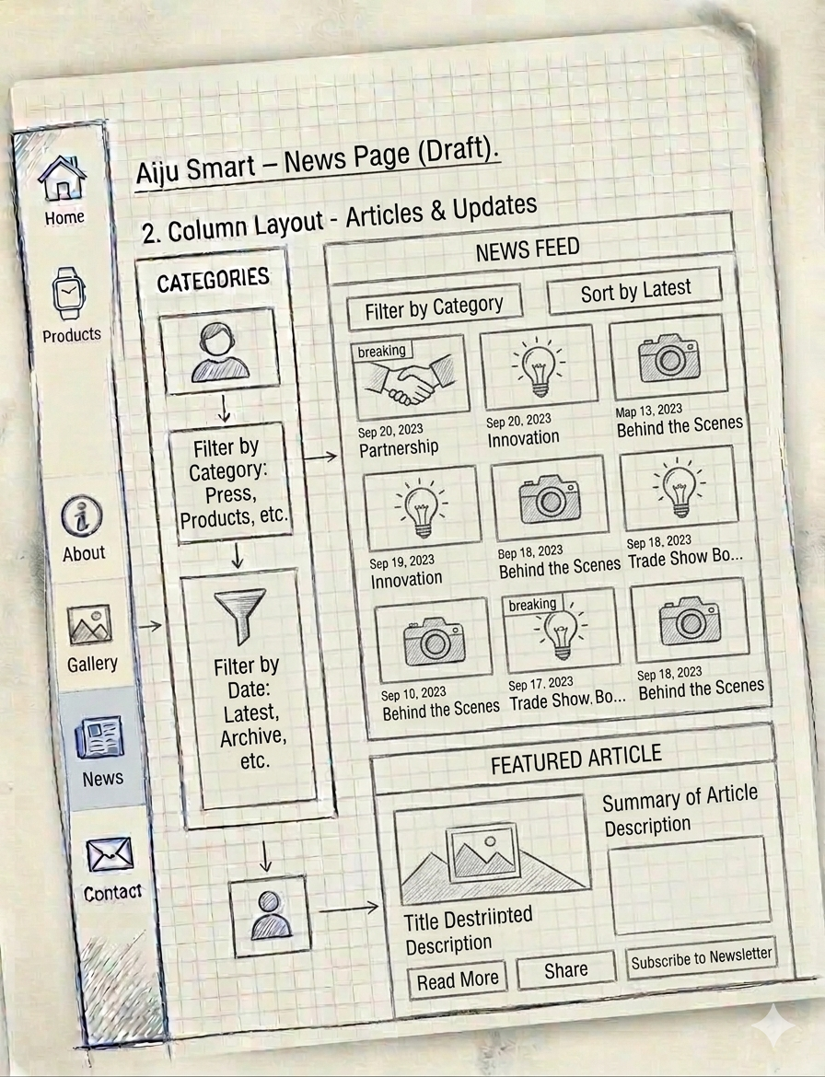
Contact page
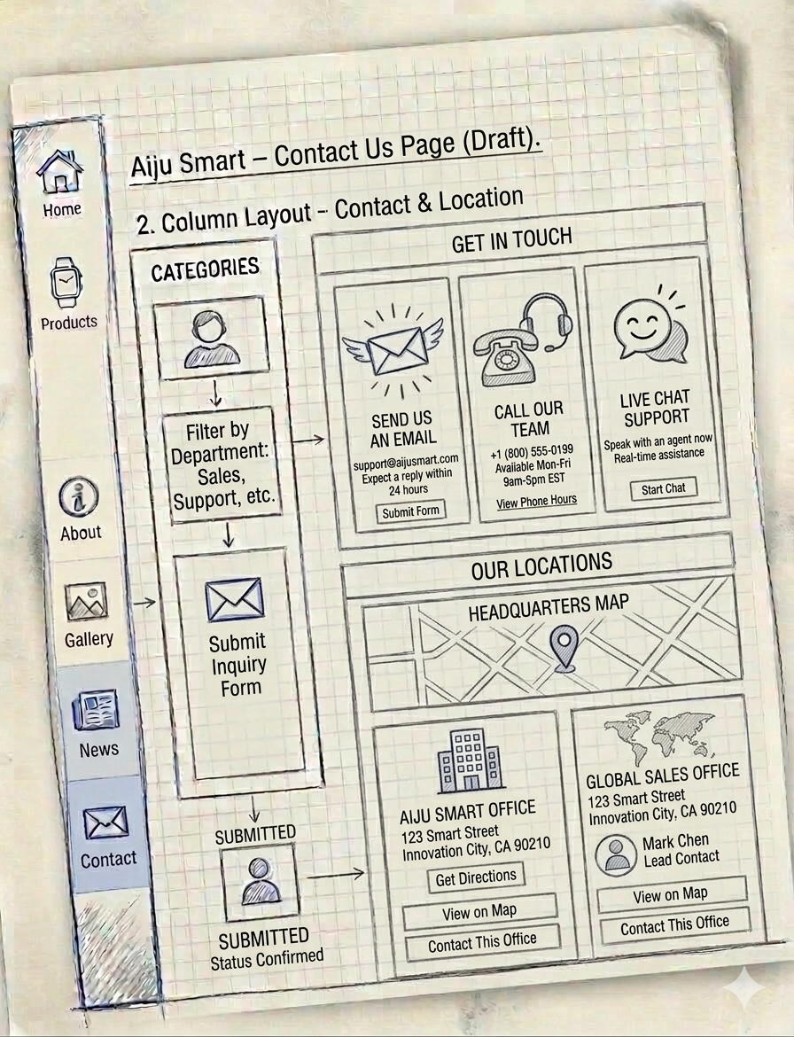

Technical Brief
- VS Code: main coding application
- GitHub: website hosting technology
- Css: main styling component of the website
- Gemini: used to build the wireframe of the site
- Bootstrap: ready-made styling elements for the website
- Flaticon: used for website icons
- Pinterest: main application used for image creation

Testing

Microsoft edge: checking if the website is accessible on Microsoft edge
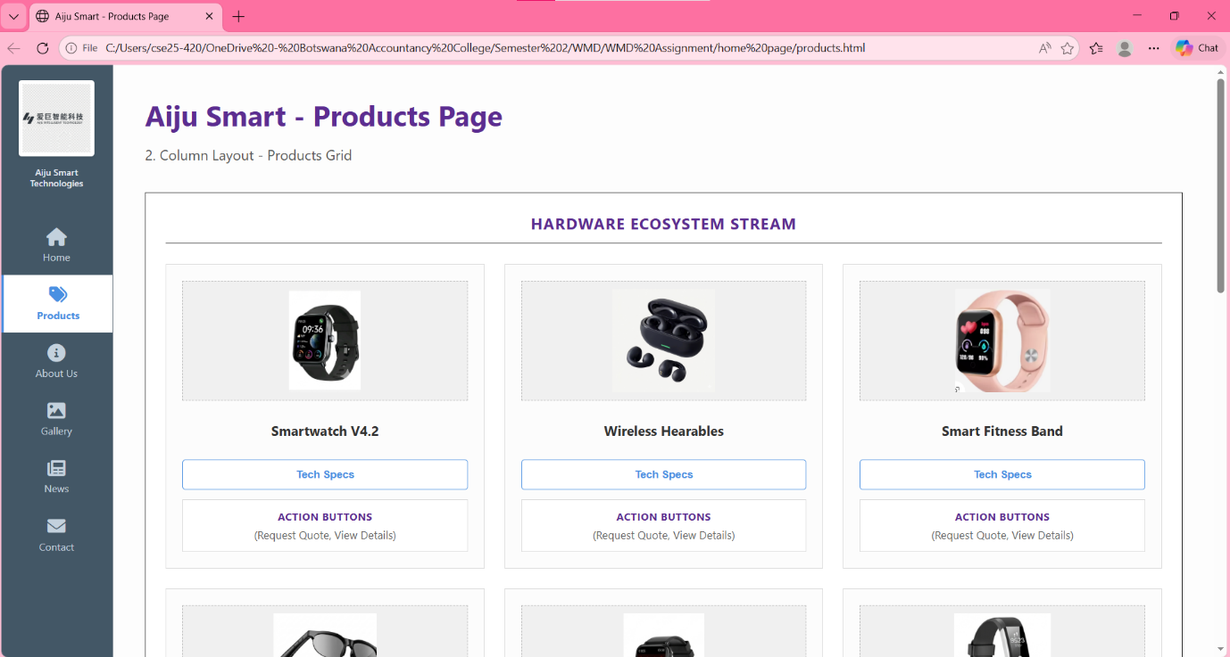

Google Chrome: checking the accessibility of website on google chrome
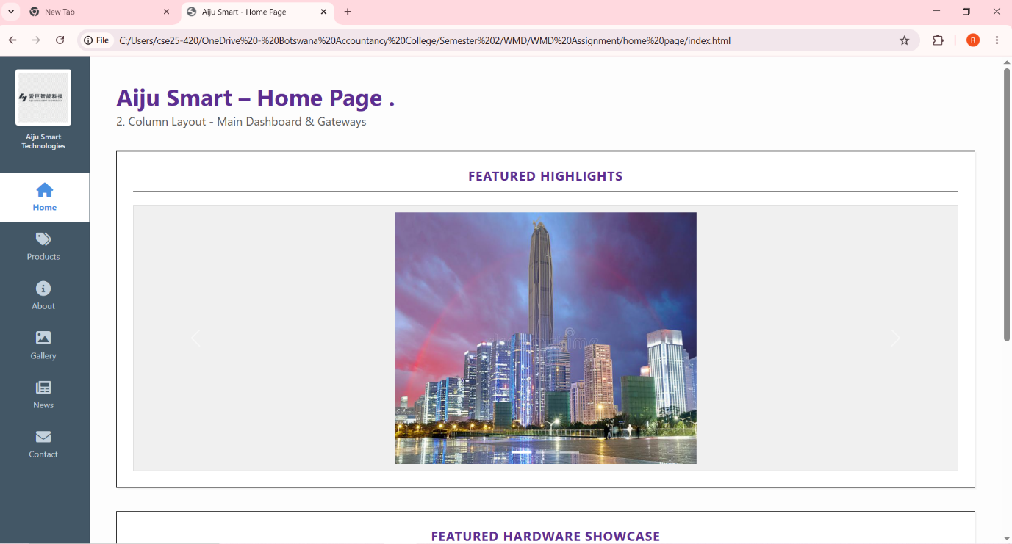

Mobile device test: testing website accessibility using a mobile device

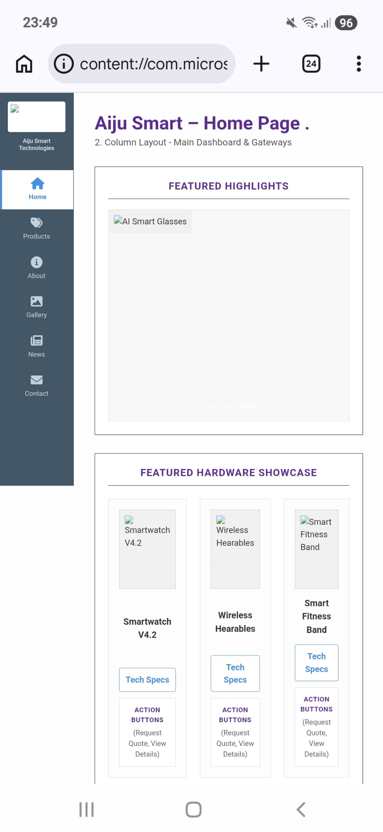

Publishing
Web hosting service provider: Github
- Create repository
- Upload repository materials
- Publish repository
Future Developments
- Add a shopping cart for direct purchasing of products
- Add login page for repetitive/ long term buyers
- Add billing page
- Multi-currency toggle

Repository URL: https://github.com/cse25-420/AijuIntelligentTechnologies
Website URL: https://cse25-420.github.io/AijuIntelligentTechnologies/

